Project Design Phase-II

Data flow diagrams and user stories

Date

Project Name

Maximum marks

14 October 2022

Project- Signs with Smart Connectivity for Better Road Safety

4 marks

Data Flow Diagram:
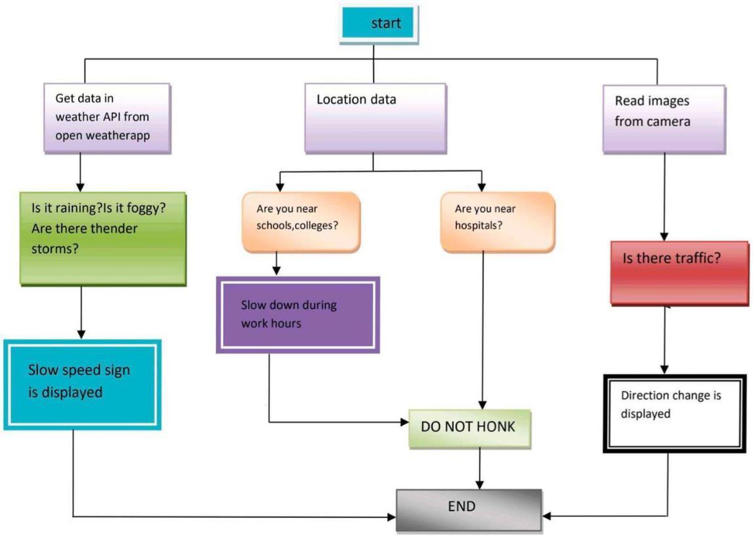

User Stories:
